The Prompt Builder: Participant Guide



Author: Loving Williams Group LLC
Contact: admin@lovingwilliams.com
Date: 2025 V1

Participant Guide: Viral Video Prompt Builder

Create. Learn. Go Viral — One Step at a Time.

Participant Guide Overview
The Viral Video AI Prompt Builder is an interactive learning tool that helps you design powerful, psychology-backed prompts for short-form videos on TikTok, YouTube Shorts, and Instagram Reels. It walks you step-by-step through the process of building prompts that grab attention, tell a story, and inspire viewers to act — even if you’ve never written a prompt before.
Think of it as your personal creative coach that makes AI content creation simple, structured, and fun.

Who This Is For
This tool is designed for:
- New or growing creators who want to understand why some videos go viral.
- Professionals or educators who want to communicate with impact.
- Adult learners who are eager to learn AI tools without tech overwhelm.

What You’ll Learn
By the end of this experience, you’ll know how to:
1. Hook attention — craft openings that stop the scroll.
2. Structure your idea — define the who, what, and how of your message.
3. Add style & emotion — make your content visually and emotionally magnetic.
4. Test and refine — generate variations that help you find your best-performing prompts.
5. Turning creativity into consistency — build a repeatable system for producing viral-ready ideas.

How the Tool Works
You’ll move through five easy steps, each one teaching a key part of viral storytelling:
1. Choose Your Experience Level — Set how much guidance you want.
2. Select Target Platform — Pick TikTok, YouTube Shorts, or Instagram Reels.
3. Build Your Viral Prompt — Create emotional hooks, structure, and style.
4. Generate Variations — Produce multiple AI-generated ideas.
5. Review Results & Save Winners — See what works and why.

Step 1: Choose Your Experience Level
Purpose: This step personalizes your learning experience based on your comfort level with AI and content creation.
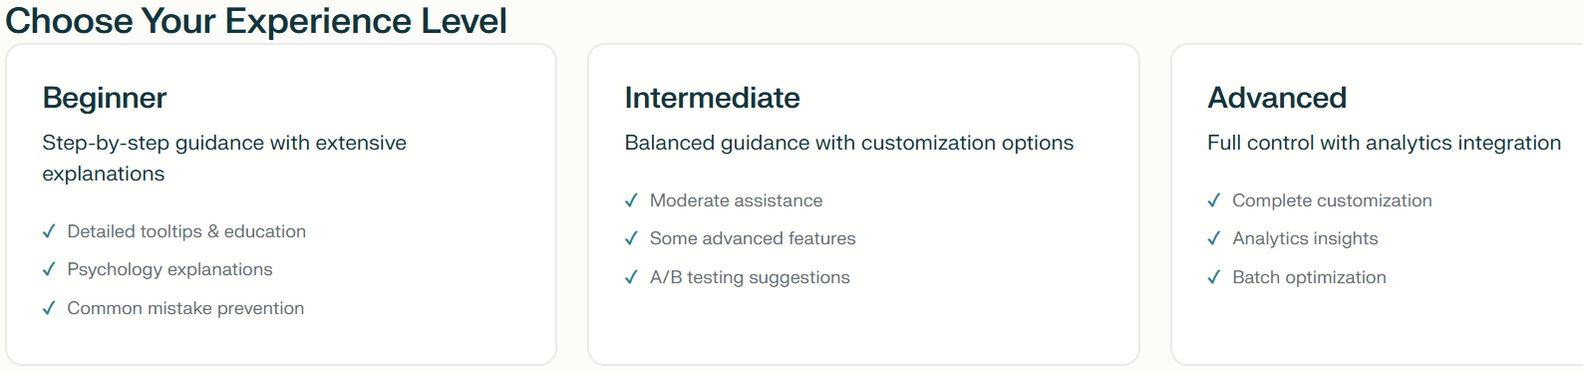
Levels:
• Beginner – Step-by-step guidance, detailed explanations, and psychology insights.
• Intermediate – Balanced guidance with customization and A/B testing suggestions.
• Advanced – Full control with analytics and optimization tools.
In Simple Terms: You’re telling the tool how much hand-holding you want. Beginners get a tour guide, intermediates get a map, and advanced users get the keys to the car.
🎓 Experience Levels Explained
Level | Who It’s For | What You’ll Get | Why You’ll Love It
Beginner | You’re brand new to prompt creation or short-form video content. | Step-by-step instructions, detailed tooltips, and psychology explanations. | You’ll feel supported, confident, and never lost — like having a coach right beside you.
Intermediate | You’ve written a few prompts or created social content before. | Balanced guidance, A/B testing ideas, and moderate customization. | You’ll grow your skills while still getting structure and smart suggestions.
Advanced | You’re experienced with AI, scripting, or marketing. | Full control over creative decisions, plus analytics and optimization insights. | You’ll move fast, test efficiently, and fine-tune like a professional strategist.

✅ Tips for Choosing:
- If you’re not sure, start with Beginner — you can always move up later.
- Think of this as a learning journey, not a test.
- The goal is to progress, not perfection — your level helps the tool teach you your way.

Notes:

Step 2: Select Target Platform
Purpose: Each social platform has its own rhythm, tone, and ideal content length. This step helps tailor your prompts for TikTok, YouTube Shorts, or Instagram Reels.
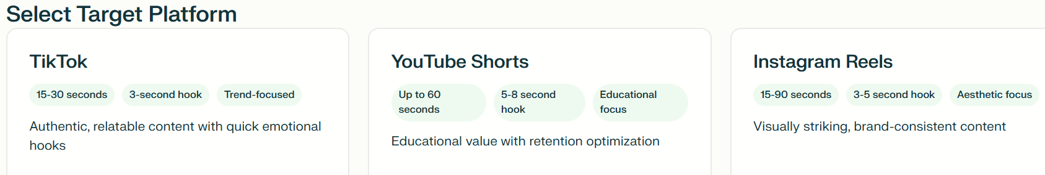
Platform Benefits:
• TikTok – Quick, emotional, trend-driven videos (15–30 sec).
• YouTube Shorts – Educational and story-based (up to 60 sec).
• Instagram Reels – Aesthetic, brand-consistent content (15–90 sec).
Why It’s Powerful to Have All Platforms in One Tool:
1. Everything in one place – no guesswork.
2. Learn multi-platform strategy easily.
3. Save time while keeping brand consistency.
4. Boost reach and confidence.
In Simple Terms: Each platform is like a different party — TikTok is fun, YouTube is smart, and Instagram is stylish. This tool helps you dress your idea for the right one.
💡 Why It’s Powerful to Have All Platforms in One Tool
- Everything in One Place — No Guesswork
You don’t have to jump between tools or apps. This single tool automatically adjusts tone, timing, and structure based on your chosen platform.
🧭 One destination, three different routes to success.
- Learn Multi-Platform Strategy Easily
Seeing all platforms side-by-side helps you understand how each one thinks.
💬 TikTok grabs attention, YouTube educates, Instagram beautifies.
- Save Time & Stay Consistent
You can create different versions of the same idea for multiple platforms in minutes — keeping your message consistent while adapting your style.
🕒 Post everywhere without rewriting everything.
- Boost Reach & Confidence
Learning how your content fits into each platform builds real-world marketing confidence.
🚀 You’ll know exactly what works where — no more guessing or hoping.

💬 In Simple Terms
Each platform is like a different party:
- TikTok is loud and fun 🎉
- YouTube Shorts is smart and helpful 🎓
- Instagram Reels is stylish and polished 💅
This tool helps you dress your idea for the right party — automatically.

Platform | Typical Length & Hook | Primary Focus | Why Choose This One
TikTok | 15–30 seconds, 3-second hook | Trends, emotions, fast reactions | Great for quick, authentic moments that feel personal and relatable.
YouTube Shorts | Up to 60 seconds, 5–8-second hook | Education, storytelling, retention | Perfect for sharing how-to content, mini-lessons, and inspiring insights.
Instagram Reels | 15–90 seconds, 3–5-second hook | Visuals, lifestyle, branding | Ideal for aesthetic content, transformation videos, or brand storytelling.

Step 3: Build Your Viral Prompt – Emotional Hook
Purpose: The hook is the first few seconds that make viewers stop scrolling. It’s what turns a good video into a viral one.
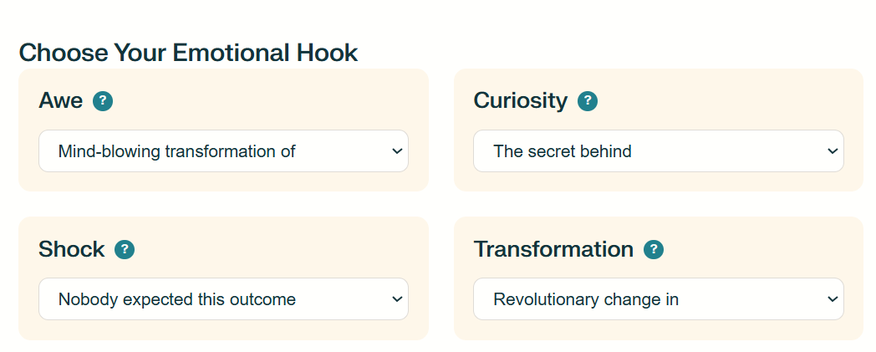
A hook is the very first thing that grabs someone’s attention — kind of like the bait on a fishing line. 🎣
In videos, posts, or stories, the hook is usually the first few seconds or the first sentence — it’s what makes people stop scrolling and say, “Wait, what’s this?”
Why a good hook matters:
- 🧠 People decide fast — you only have a few seconds before they move on.
- 👀 A strong hook makes them curious — they want to see what happens next.
- 💰 It’s the difference between viral and invisible — if your hook is weak, nobody sticks around long enough to see your great content.
In simple terms:
A hook is what makes people stop, look, and care — without it, they’ll just keep scrolling.
Hook Types:
• Awe – Wonder and amazement (‘Breathtaking moment when…’)
• Curiosity – Triggers interest (‘The secret behind…’)
• Shock – Surprise (‘Nobody expected this outcome’)
• Transformation – Inspiration (‘From zero to hero in…’)

Here’s a table summarizing all Emotional Hook Types and their corresponding dropdown options from the tool, along with concise one-line descriptions for each:
Emotional Hook Type | Dropdown Choice | One-Line Description
Awe | Mind-blowing transformation of | Highlights a dramatic and astonishing change that evokes wonder.
 | Incredible before/after showing | Displays an impressive visual or outcome comparison.
 | Stunning revelation about | Reveals an unexpected and jaw-dropping fact or truth.
 | Breathtaking moment when | Captures a visually or emotionally awe-inspiring instant.
Curiosity | The secret behind | Promises to uncover hidden knowledge or insight.
 | What nobody tells you about | Suggests exclusive information not commonly shared.
 | The shocking truth about | Exposes surprising or lesser-known facts that grab attention.
 | You won't believe what happens when | Build suspense by hinting at an unbelievable result.
Shock | This will change everything you know about | Challenges existing beliefs with disruptive information.
 | The most surprising thing about | Reveals an unexpected twist or counterintuitive detail.
 | Nobody expected this outcome | Emphasizes an unforeseen result or reversal.
 | This breaks all the rules of | Introduce something that defies conventions or norms.
Transformation | From zero to hero in | Highlights rapid or impressive personal growth or achievement.
 | Complete makeover of | Focuses on a full, visible, or metaphorical transformation.
 | Revolutionary change in | Describes a game-changing improvement or innovation.
 | Dramatic evolution of | Showcases progressive and significant development over time.

Notes

Step 4: Define Core Elements
Purpose: Define the visual and storytelling foundation of your prompt.
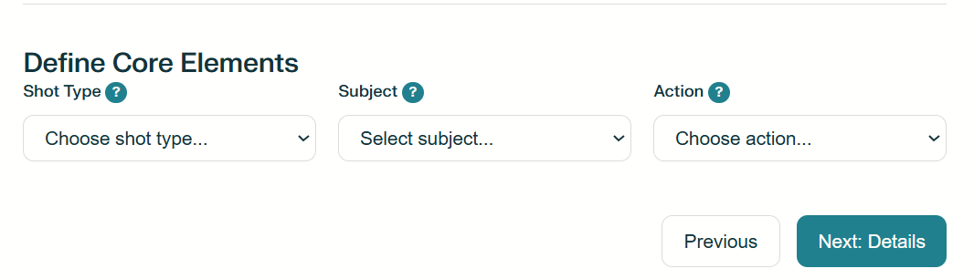
Core Elements:
• Shot Type – How it looks (close-up, wide shot, over-the-shoulder).
• Subject – Who or what it’s about (person, object, idea).
• Action – What’s happening (creates, reveals, teaches).
Simple Terms: Shot = how it looks, Subject = who it’s about, Action = what happens. Together they make your video easy to understand and engaging.
💡 Why Core Elements Matter (in simple terms):
- Shot Type → How your viewer sees the story controls emotion and focus.
🧠 Think of it like picking the right camera angle in a selfie — it changes everything!
- Subject → Who or what your video is about — the star of the story.
👀 People connect to people, objects, or ideas that feel real or interesting.
- Action → What’s happening — it gives movement and meaning.
⚡ Without action, your video is just a picture — action keeps it alive.

In short:
👉 Shot = how it looks
👉 Subject = who/what it’s about
👉 Action = what’s happening
All three together make your video watchable, clear, and worth finishing.
Here’s a table summarizing all Core Elements and their corresponding dropdown options from the tool, along with concise one-line descriptions for each:
🧩 DEFINE CORE ELEMENTS TABLE
Core Element | Dropdown Choice | One-Line Description
Shot Type | Close-up | Shows emotion or detail up close for stronger connection.
 | Medium shot | Frames the subject naturally, showing body language.
 | Wide shot | Shows the full scene or environment for context.
 | Over-the-shoulder | Puts the viewer “in the moment” with the subject’s view.
 | Bird’s eye view | Looks straight down to give a unique perspective.
 | Low angle | Makes the subject look powerful or important.
 | High angle | Makes the subject look small, weak, or vulnerable.
 | Split screen | Shows two things happening side-by-side for contrast.
Subject | Young entrepreneur | A fresh, ambitious person building something new.
 | Wise elderly person | Someone older sharing life experience and wisdom.
 | Everyday hero | A normal person doing something inspiring.
 | Expert craftsperson | A skilled person showing mastery of their craft.
 | Unlikely teacher | Someone unexpected who has something to teach.
 | Passionate artist | Creative soul expresses emotion through art.
 | Determined athlete | Someone pushing physical or mental limits.
 | Innovative scientist | A thinker creating or discovering something new.
 | Ordinary household item | A common object shown in an interesting way.
 | Forgotten vintage piece | Something old rediscovered or reused.
 | High-tech gadget | Cool modern technology in action.
 | Natural phenomenon | Something amazing that happens in nature.
 | Artistic creation | Beautiful artwork being made or revealed.
 | Everyday tool | A basic tool shown by doing something unexpected.
 | Surprising product | An item that does more than it seems.
 | Life-changing habit | A small action that has a big positive impact.
 | Hidden opportunity | Something most people overlook has value.
 | Powerful mindset shift | A new way of thinking that changes perspective.
 | Revolutionary technique | A totally new method that works better or faster.
 | Unexpected solution | A clever or surprising fix to a common problem.
Action | demonstrates a technique | It shows exactly how to do something step by step.
 | reveals hidden feature | Exposes something cool most people didn’t know about.
 | transforms appearance | Changes how something looks in a big way.
 | solves complex problem | Fix something that seems difficult or impossible.
 | creates something beautiful | Makes something visually pleasing or artistic.
 | breaks conventional rule | Goes against what’s normally expected.
 | teaches valuable lesson | Shares an insight or moral worth remembering.
 | overcomes major obstacle | Conquers a big challenge or setback.
 | discovers breakthrough | Find something brand new or game changing.
 | shares secret method | Reveals a personal trick or shortcut for success.

Notes:

Step 5: Style & Atmosphere
Purpose: Add the look, feel, and sound that give your video emotion and visual impact.
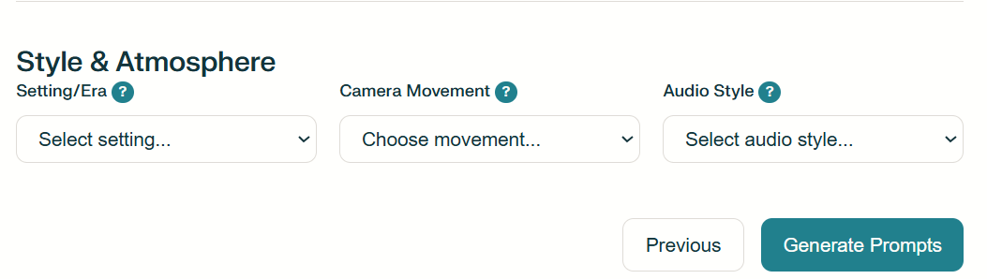
Elements:
• Setting/Era – The environment or time period (1980s neon, modern minimalist).
• Camera Movement – Adds motion (pan reveal, time-lapse, crane shot).
• Audio Style – Sets tone (motivational music, lo-fi beats, cinematic score).
💡 Why Style & Atmosphere Matter (in simple terms):
- Setting/Era → Where and when your story happens — it gives your video personality.
🎨 It’s like picking the background in your selfie — it totally changes the vibe.
- Camera Movement → How your camera moves — it makes things feel alive or calm.
🎥 Motion keeps eyes glued to the screen — still shots can feel boring.
- Audio Style → What it sounds like sets the mood instantly.
🎧 Music and sound make people feel something before they even think.

🧠 In super-simple terms:
Style & atmosphere are what make your video look cool, feel right, and stick in people’s minds.
They turn a plain video into a mood that people remember.
Here’s a table summarizing all Style & Atmosphere elements and their corresponding dropdown options from the tool, along with concise one-line descriptions for each:

Element | Dropdown Choice | One-Line Description
Setting / Era | 1920s Art Deco era | Glamorous, geometric vintage style full of luxury.
 | 1950s Americana | Nostalgic, diner-style, classic U.S. post-war vibe.
 | 1980s neon aesthetic | Bright, colorful, and retro with glowing lights.
 | Modern minimalist | Clean, simple, and clutter-free look.
 | Futuristic cyber-punk | Dark, techy, neon-filled futuristic world.
 | Medieval fantasy | Castles, knights, and magic — old-world adventure feel.
 | Victorian elegance | Fancy, detailed, and old-fashioned beauty.
 | Contemporary urban | Modern city life — fast, real, and relatable.
 | cozy home workshop | Warm, handmade, personal space vibe.
 | bustling city street | Busy, energetic, and full of life.
 | serene natural landscape | Peaceful outdoor beauty — calm and relaxing.
 | high-tech laboratory | Sleek, scientific, and full of cool gadgets.
 | vintage coffee shop | Warm lighting and creative, artsy atmosphere.
 | dramatic rooftop | High place with wind, sky, and emotion.
 | intimate studio space | Personal, close-up, behind-the-scenes feel.
 | public gathering place | Crowded, energetic, social environment.
 | peaceful garden | Calm, green, nature-filled serenity.
 | industrial warehouse | Rugged, raw, urban aesthetic with textures.
Camera Movement | smooth dolly push-in | Slowly moves closer to build emotion or focus.
 | gentle pan reveal | Moves sideways to reveal new information smoothly.
 | dynamic rotation around subject | Circles the subject to show energy or excitement.
 | slow-motion capture | Slows down motion to emphasize drama or beauty.
 | time-lapse progression | Speeds up time to show change or growth.
 | steady focus pull | Shifts focus from one object to another smoothly.
 | tracking shot following action | Moves with the subject for immersive feeling.
 | crane shot rising up | Moves upward for a big, cinematic reveal.
 | handheld documentary feel | Natural, slightly shaky — feels real and unscripted.
 | locked-off static frame | Camera doesn’t move — calm and focused shot.
Audio Style | upbeat motivational music | Energetic and inspiring background music.
 | gentle acoustic background | Soft and friendly, often guitar based.
 | dramatic orchestral build | Big, emotional, movie-style music.
 | modern electronic beats | Trendy, techy sound with rhythm and bounce.
 | natural ambient sounds | Real-life noises like wind, birds, or water.
 | vintage jazz undertones | Smooth, classy, old-school vibe.
 | epic cinematic score | Powerful, sweeping music for emotional impact.
 | lo-fi chill beats | Relaxed, mellow, and modern background vibe.
 | energetic pop rhythm | Catchy and fun — perfect for upbeat content.
 | atmospheric soundscape | Soft background sounds that set a mood.

Step 6: Generation Options
Purpose: Choose how many variations the AI should create — giving you multiple ideas to test.
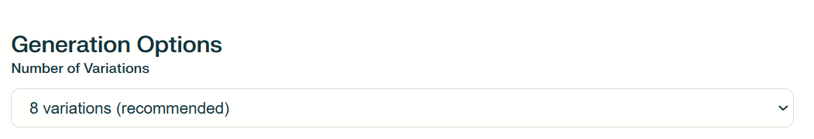
Options:
• 4 Variations – Quick test set.
• 8 Variations – Balanced variety (recommended).
• 12 Variations – Maximum creativity and test data.
💡 Why Generation Options Matter (in simple terms):
- More variations = more chances to win.
📊 Each version is like a lottery ticket — the more you test, the higher your chances of finding a viral hit.
- AI helps you see angles you’d never think of.
🧠 Trying different versions shows you creative hooks or visuals you might have missed.
- It kills perfectionism.
🚀 Instead of wasting time making one perfect video, you make many good ones and see what works best.

🧠 In super-simple terms:
The Generation Options decide how many tries you give yourself to find a viral idea.
More tries = more data, more creativity, and a better shot at going viral.
Here’s a table summarizing all Generation Options and their corresponding dropdown options from the tool, along with concise one-line descriptions for each:

Element | Dropdown Choice | One-Line Description
Number of Variations | 4 variations | Creates 4 different prompt ideas — quick sample test.
 | 8 variations (recommended) | Creates 8 different prompt ideas — best balance for testing.
 | 12 variations | Creates 12 different prompt ideas — widest range for deep testing.

Step 7: Results & Next Steps – From Prompts to Profit
Purpose: Analyze your generated prompts, test variations, and learn how to use winning ideas to grow your brand and income.

Next Steps:
1. Test 3–4 versions and monitor retention.
2. Track engagement metrics (comments, likes, shares).
3. Save your best-performing prompts.
4. Repurpose successful content for multiple platforms.
Profit Strategies:
• Sponsorships – Collaborate with brands.
• Affiliate Sales – Link to products you recommend.
• Digital Products – Sell guides, templates, or courses.
• Brand Partnerships – Turn your style into a service.
Simple Terms: This is the 'show me the money' step — where creativity meets income potential.

Step 8: Saved Prompts & Ongoing Practice
Purpose: Build a personal AI prompt library you can refine, reuse, and repurpose over time.
Tips for Use:
• Review saved prompts weekly.
• Refine winners for new topics.
• Create themed series using proven hooks.
• Track performance over time.
Simple Terms: Your saved prompts are like favorite recipes — you can always tweak them, but you already know they work.
Why Practice Matters: The more you build, the faster you learn what works. Each session strengthens your creative instincts and confidence.

